# Assignment

# Module- 1(Fundamental)

### What is SDLC?

SDLC is a framework that defines the step involved in the development of software at each phase. It covers the details plan for building, deploying and maintenance the software. SDLC defines the complete cycle of development i.e. all the task involved in planning, creating, testing, deploying a software product.

### what is software testing?

Software testing is a process that used to identify the correctness, completeness and the quality of developed computer software.

### What is agile methodology?

Agile SDLC model is a combination of iterative and incremental process model with the focus on process adaptability, and customer satisfaction by rapidly delivery of working software product.

### What is SRS?

A software requirement specification (SRS) is a document that captures complete description about how the system is expected to perform. It is usually signed off at the end of requirement engineering phase.

### What is oops?

OOP is an object-oriented programming technique that combine data and instruction for the processing that data into an object that can be used within the program. OOPs provide concepts that help modeling complicated systems of real world into manageable software solution.

### Write basis concepts of oops?

1. Object
2. Class
3. Encapsulation
4. Inheritance
5. Polymorphism
   1. Overriding
   2. overloading
6. abstraction

### What is object?

It is a basic unit of object-Oriented programming and represent an individual item, unit or real-life entities, with a well defined role in the problem domain.

### What is class?

A class represents an abstraction of the object and abstraction of the properties and behavior of that object. Simply its blueprint for an object.

### What is encapsulation

Encapsulation is the practice of including in an object everything it needs hidden from other objects. The internal state is usually not accessible by other objects.

### What is inheritance

Inheritance means that one class inherits the characteristics of another class. This is a very important concept of OOP since this feature helps to reduce the code size.

### What is polymorphism?

The word polymorphism means having many forms. In simple words, we can define polymorphism as the ability of a massage to be displayed in more than one form. For example, A person at the same time can be different characteristics. Like a man at the same time is a father, a husband, an employee. So the same person posses different behavior in different situations. This is called polymorphism.

### Draw usecase on online book shopping

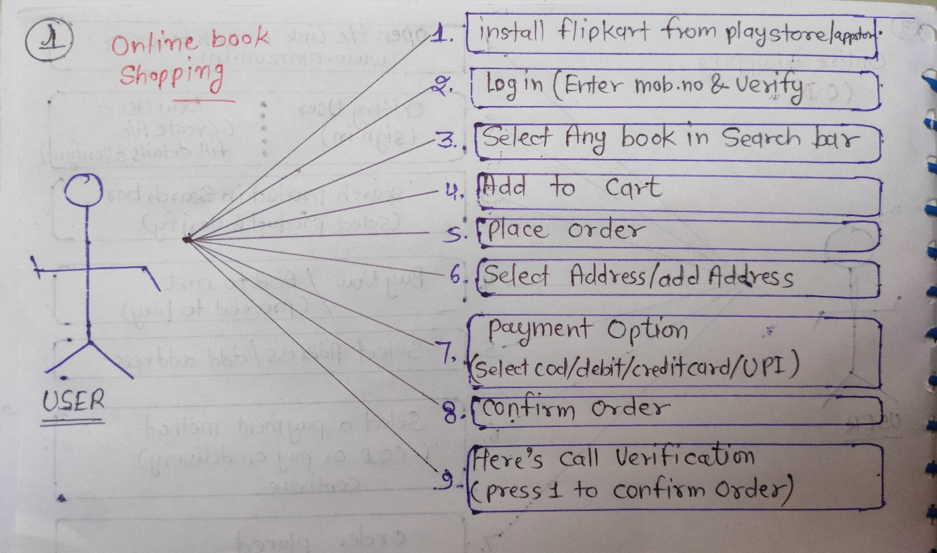

### Draw usecase on online bill payment system (paytm)

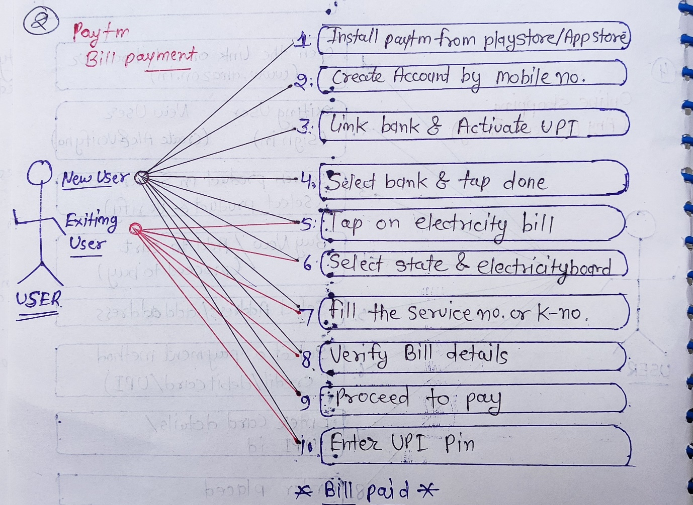

### Write SDLC phases with basic introduction.

|  |  |
| --- | --- |
| Requirement gathering | Collect the customer needs |
| Analysis | Model And specify the requirement – “What”  (analysis the customer requirement) |
| Design | Model and specify a solution – “why”  (let’s do a design architecture documents) |
| Implementation | Develop the software |
| Testing | Validate the solution against the requirements |
| Maintenance | Repair defects |

### Explain phases of the waterfall model.

The sequential phases of waterfall model are-

1. **Requirement collection: -** collect the requirement from the customer
2. **Analysis: -** All possible specify requirement goes for analysis
3. **Design: -** design architecture document
4. **Implementation: -** it’s developer task
5. **Testing: -** validate the solution against the requirement
6. **Maintenance: -** Repair defects and adapt the solution to the new requirement

### Write phases of spiral model.

Initial requirements

1. Planning: - determination the object
2. Risk analysis: - analysis of alternative and identification of risks
3. Engineering: - development of the “next level” product
4. Customer Evaluation: - Assessment of the results of engineering

completion

### Write agile manifesto principles.

1. Individual interaction
2. Working software
3. Customer collaboration
4. Responding to change

### Explain working methodology of agile model and also write pros and cons.

Agile SDLC model is a combination of iterative and incremental process model with the focus on process adaptability, and customer satisfaction by rapidly delivery of working software product

**PROS :-**

* Suitable for fixed or changing requirements
* Easy to manage
* Gives flexibility to developers
* Minimum rules, documents easily employed
* Delivery early partial working solution

**CONS :-**

* More risk of sustainability, maintainability and extensibility
* High individual dependency
* Depends heavily on customer interaction, so if the customer is not clear, team can be driven in the wrong direction
* Transfer of technology to new hands may be quite challenging

### Draw usecase of online shopping product using COD

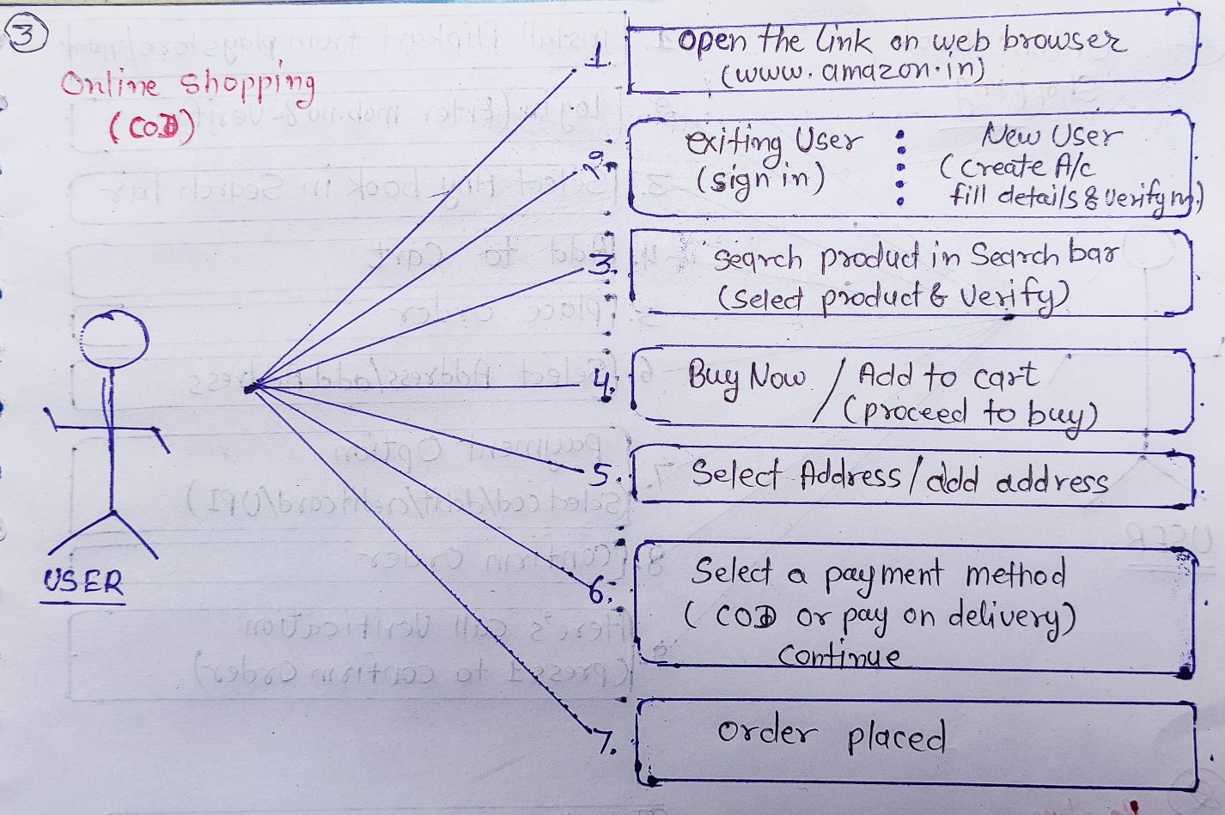

### Draw usecase of online shopping product using payment gateway.

